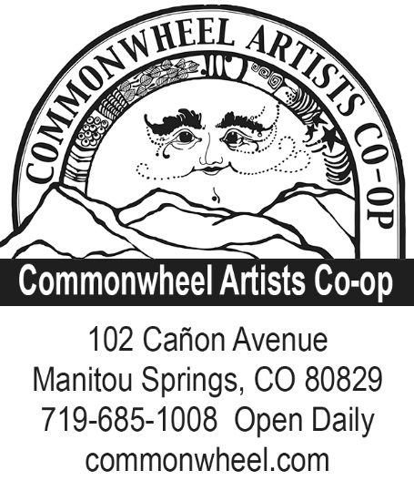
2019 Commonwheel Artists Co-op
Gallery Show Application
Commonwheel Artists Co-op offers a unique opportunity to visual artists in our gallery space. Our mission is to “encourage both members and visiting artists by providing a venue for the exhibition and sale of their work in the Pikes Peak Region.” As part of this mission we solicit show submissions from both outside and within of our co-op membership. Each gallery show brings its own audience and makes customers more aware of Commonwheel and the local artists whose work we exhibit.
We encourage our Gallery artists to create new work for their shows. New work inspires the artist, and offers opportunity to explore new areas of your medium, or a different medium. Often the outcome from such explorations informs the artist’s routine work with new direction or insights.
Our artist’s receptions for these gallery shows will feature an Artist’s Reception and integrate music, food, and the work itself, creating a genuine event that generates excitement about the work. Patron enthusiasm for the work in the gallery is expected to generate sales of the gallery work.

Commission Rate: Artist/Commonwheel split is 60% / 40% for non-Commonwheel members. This translates to 60% of each sale going to the artist and 40% to Commonwheel.

Jury Fees: $10 per artist involved with your application or $50 for groups of 5 or more artists.

Things to consider as you complete your application:
If you
- are an individual artist, please describe the type(s) of work you would show with us.
- represent a group of artists, please describe the common theme that will bring your various works together into one show.
- are a Commonwheel member, please describe how your show will differ from what you have in the shop now.

Please describe in your application how you plan on using the wall and/or floor space. If you are unfamiliar with our gallery space, you’ll find a virtual tour on our blog.

Include images of artwork similar to what would be in your show. Digital prints, photos or CDs are preferred.

Artist’s Receptions: Commonwheel will provide wine, punch, chips and dip. Artists are required to contribute additional food for their openings. This could be a fruit platter, vegetable platter with dip, cheese and cracker plate, or some kind of dessert.

Publicity Plans:
Online: Commonwheel will email invitations to our mailing list of over 2,500 as well as other social media outlets, and we encourage gallery artists to do the same. If an artist has other contacts they are encouraged to use them. (Please complete the social media information on page 3.) We also plan to interview gallery artists and compile a blog post to publicize your art and your gallery show.

Printed: Commonwheel provides a counter flyer for promotion at our front desk. Additional designed and printed pieces, such as postcards and posters are available for a charge.

Broadcast: We send press releases to various news outlets, websites, television and radio outlets, and online event calendars.

2019 Gallery Show Application

Name: Medium:
Address: Phone:
City: State: Zip:
E-mail:
Month or seasonal preference:

Title of Proposed Show:
Description of your Proposed Show’s Theme:

Participating Artists Media Price range Wall/Floor

When filling out this form, please give as much detail about your ideas as possible. Feel free to use another sheet if necessary. Planned details show the level of commitment to a quality show.

Please include with your submission:
- Completed Gallery Show Application
- Artwork Images: digital prints, photos, or CDs
- Jury Fee ($10 per artist represented on this application or $50 for groups of 5 or more)
- Social Media Information

Please drop off, or mail this form Attn.: Gallery Shows 2019
before July 1, 2018 to: Commonwheel Artists Co-op
102 Cañon Avenue
Manitou Springs, CO 80829
Social Media Information
(Please fill in any/all that apply)
Facebook personal page:
Facebook business page:
Instagram:
Twitter:
Pinterest:
YouTube Channel:
Etsy page:
Other Social Media outlets:

Do you have a personal email list?

